**Ex. No: 1**

**Date:**

**BASIC LINUX COMMANDS**

**Problem Statement:**

To execute basic Linux commands.

**Problem Description:**

To execute all the basic Linux commands with various options:

**1. ls - List Files**

* Description: Lists files and directories in the current directory.
* Synopsis: ls [options] [files or directories]
* Options:

1. -l: Long format, providing detailed information about files.
2. -a: Include hidden files (those starting with a dot).
3. -t: Sort by modification time.

* Syntax: **ls -l, ls -a, ls -t**

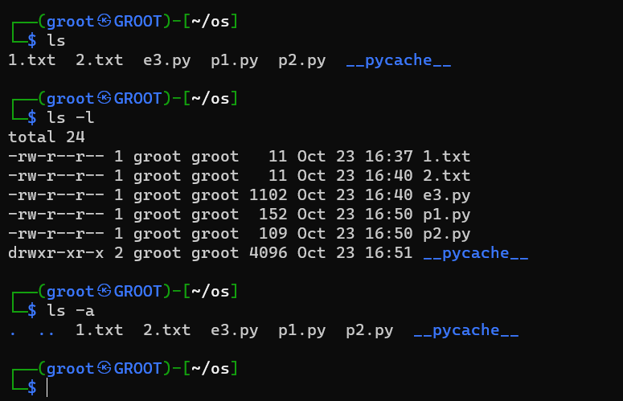

**2. cat** - Concatenate and Display Files

* Description: Displays the contents of one or more files.
* Synopsis: cat [options] [files]
* Options:

1. -n: Number lines when displaying the file.
2. -E: Show a "$" at the end of each line.
3. -s: Squeeze multiple blank lines into one

* Example: cat filename.txt

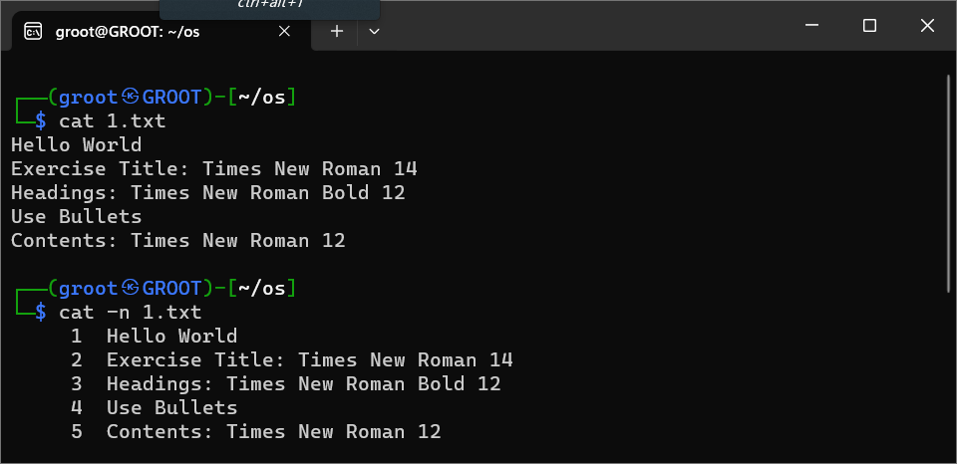

**3. ps - Process Status**

* Description: Displays information about running processes.
* Synopsis: ps [options]
* Example: ps aux

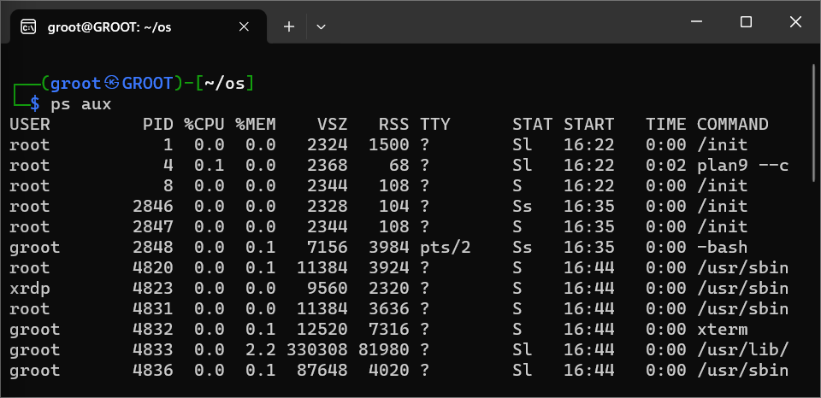

**4. cp - Copy Files and Directories**

* Description: Copies files or directories from one location to another.
* Synopsis: cp [options] source destination
* Example: cp file.txt newfile.txt

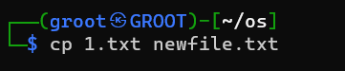

Newfile.txt will be created with all the contents in oslab.txt

**5. echo - Print Text**

* Description: Prints text to the terminal.
* Synopsis: echo [options] [text]
* Example: echo "Hello, World"

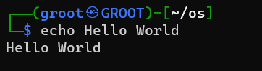

**6.** **cmp - Compare Two Files**

* Description: Compares two files byte by byte and displays the first differing byte's offset.
* Synopsis: cmp [options] file1 file2
* Example: cmp file1.txt file2.txt

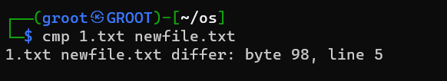

**7. pwd - Print Working Directory**

* Description: Displays the current working directory's absolute path.
* Synopsis: pwd
* Example: pwd

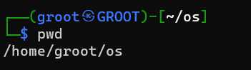

**8. rm - Remove Files and Directories**

* Description: Deletes files and directories.
* Synopsis: rm [options] [files or directories]
* Example: rm file.txt

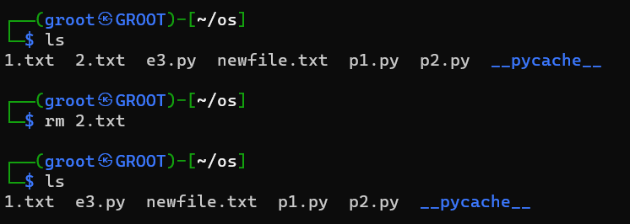

**9. mv - Move or Rename Files and Directories**

* Description: Moves or renames files and directories.
* Synopsis: mv [options] source destination
* Example: mv oldfile.txt newfile.txt

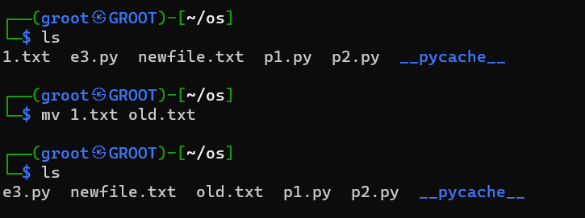

**10. touch - Create Empty Files**

* Description: Creates empty files or updates access and modification timestamps.
* Synopsis: touch [options] [files]
* Example: touch newfile2.txt

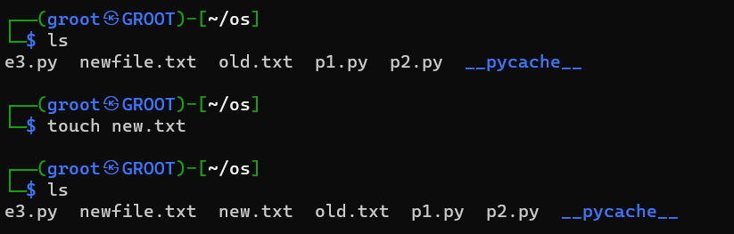

**11. chmod - Change File Permissions**

* Description: Modifies file permissions (read, write, execute) for users, groups, and others.
* Synopsis: chmod [options] mode file
* Example: chmod 500 newfile.txt

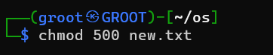

**12. clear - Clear the Terminal**

* Description: Clears the terminal screen.
* Synopsis: clear
* Example clear

**13. man - Manual Pages**

* Description: Displays the manual page for a given command or topic.
* Synopsis: man [command or topic]
* Example: man mv

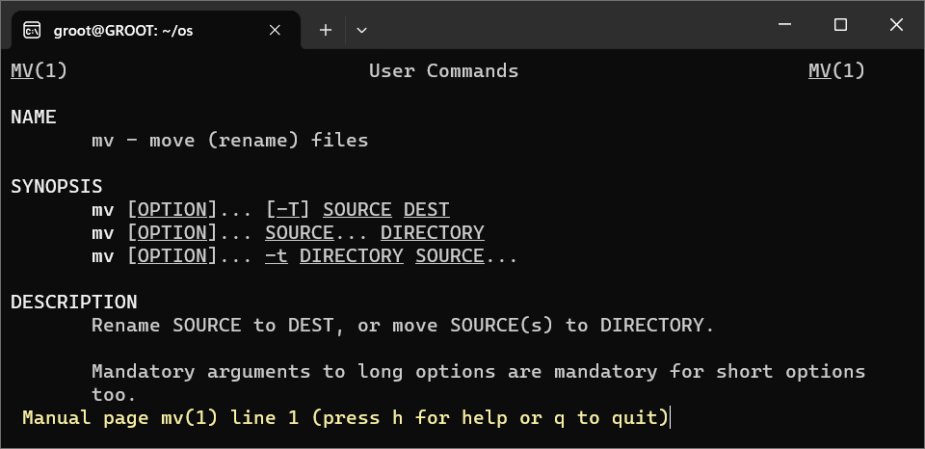

**14. more - View Text Files Page by Page**

* Description: Allows you to view the contents of a text file one page at a time.
* Synopsis: more [options] file
* Example: more tewfile.txt

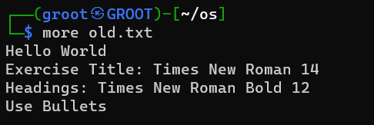

**15. less - View Text Files Page by Page (with backward navigation)**

* Description: Similar to more, but allows backward navigation through the text.
* Synopsis: less [options] file
* Example: less newfil2.txt

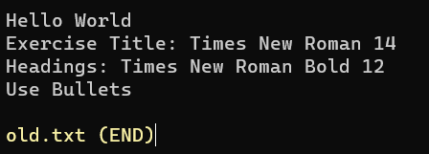

**16. grep - Search Text**

* Description: Searches for a pattern or text within one or more files.
* Synopsis: grep [options] pattern [files]
* Example: grep “A” newfile.txt

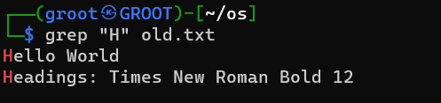

**17. head - Display the Beginning of Files**

* Description: Displays the first few lines of a text file.
* Synopsis: head [options] [files]
* Example: head newfile2.txt

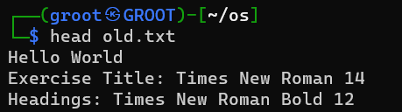

**18. tail - Display the End of Files**

* Description: Displays the last few lines of a text file.
* Synopsis: tail [options] [files]
* Example: tail newfile2.txt

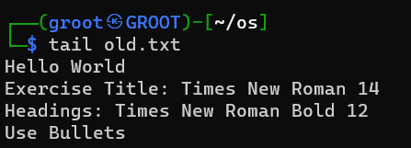

**19. sort - Sort Lines in Text Files**

* Description: Sorts the lines in a text file.
* Synopsis: sort [options] [files]
* Example: sort newfile2.txt

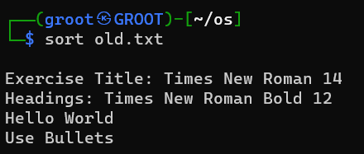

**20. whoami - Display Current User**

* Description: Displays the username of the current user.
* Synopsis: whoami
* Example: whoami

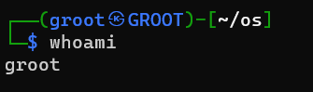

**Result:**

Thus, all the basic linux commands were executed successfully